Children Being Tortured & Killed
February 7, 2018

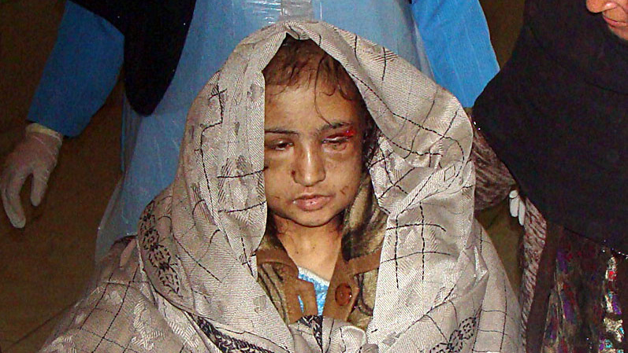
Lord Jesus, thank you for giving us the opportunity to co-labor with you in the salvation of souls. Please make our hearts steadfast and resolute, especially in times of difficulty. Amen.

Lord, I don't know what to say… What a darkness this has been; evil beyond comprehension. Thank you for letting us be a part of helping these little ones.

Dear Heartdwellers, several times now, when Ezekiel is in the thick of it with stabbing pains in his abdomen, he witnesses the brutal killing of an innocent child sold into sex trafficking. It is always unspeakably horrible, and on our end, we pray for the release of the soul from their physical body and the physical torment they are going through. He sees ordinary businessmen and soccer moms engaged in this.

Tonight, he felt like he was being disemboweled, and after a lot of prayer, we realized it was a suffering for a child that was being ritually murdered and tortured in a warehouse somewhere in Montana. This went on for a good 45 minutes.

As soon as we prayed for the release of this soul from her little body, his pain began to stop and she was released. And in that next moment, in the Lord’s arms as a beautiful little Indonesian girl named Alice, who was sold by her mother into supposedly a better life, working as a servant for the wealthy. When, in fact, she was taken captive into the horror of horrors: sex trafficking and the brutal ritual abuse of criminal Satanists. Tonight, at one thirty a.m. in Montana, she was released from her little body and taken to Heaven.

Ezekiel has seen many children taken into the Lord’s arms and received by the Father with endless kisses, and balloons, all kinds of celebration as she receives her eternal home in Heaven. There are many children in this Paradise setting, all of them rescued, and none of them remember anything about their time on Earth. They are free, full of joy and meeting all of their new-found friends.

This whole event is the most brutal and animalistic behavior that even the worst ravaging beasts would not conceive of.

How can this be Lord? How can this be?

Interceding against this leaves one limp and lifeless, so unspeakable are the horrors these little ones go through.

When I came to write this for you, I thought, ‘Alice is not an Indonesian name?’ And I looked it up. Would you believe what I?

This is a woman describing her problem with not having the right name. She's being questioned by an official.

The official answered her, “Alice. Alice WHAT?" The official asked.

"I can't even begin to recall the number of times I've been asked this question. I'm from Indonesia, a country where many Javanese people only have one name. But they often have cool names like Supardi or Sarinem. Mine is a saccharine, over-prescribed, Disney name that's neither 'exotic' enough or long enough to sustain itself abroad.

"And I'm Chinese-Indonesian, not Javanese—so when a lot of immigration officers see my face and my foreign passport, they expect a long, difficult-to-pronounce name. Instead they get... 'Alice.'"

And that was the end of her quote.

I found this somewhere on the Internet when I asked that question, about that being and Indonesian name. Anyway, I felt like Holy Spirit brought this up on the search engine as a confirmation of what really and truly happened tonight.

Well, moving onward. Ezekiel has had many spiritual experiences and been given tremendous insight into the lives and problems of some individuals. As you know, we live in a war zone and you can become weary if you don't cleave to the Lord with all your heart, strength and understanding.

What I have to say is, even if you DO cleave to the Lord with all of that - you still become weary. But when a time of refreshing comes, great insights and experiences with the Lord manifest and bring such consolation - you’d do it all over again.

So it has been with Ezekiel on and off for the last three weeks. Nonetheless, there is a price to pay for this kind of standing in the gap, as several people are praying in the Spirit and pleading with the Lord for mercy.

We have come to recognize that many times these attacks happen at a key moment, when I was just about to receive a message from the Lord. And of course, the intensity of prayer leaves me very weak. However, tonight I purposed in my heart not to leave you guys without a message.

Even though the opposition is tremendous and against me to listen for messages and fight off wild beasts to get to a message, I could not turn in tonight. I just had to share with you some of the intercessory experiences you might encounter in praying for the World.

Now, 'praying for the world' is kind of a nebulous prayer intention, but when you draw these innocent little children into the equation, it becomes a serious war and a fight to stand and live—or give up and die.

So, thank you for your prayers. Giving up is not an option.

At this point I asked, "Lord, do You have something to add?"

He began, “My children, the evil in this world is beyond your ability to imagine. It is so subtle and unrecognizable from the surface, and I have many such warriors who take on the sufferings of these little ones to release them from their agonizing prison of hopelessness. So many of them are homebound and unable to lead normal lives, (He's talking about the intercessors here) but they find their total fulfillment in living for others and interceding.

“These will be queens and kings in Heaven and be given many responsibilities to shoulder for their brothers and sisters, whether in Heaven or on Earth. My Body is one and we are all interconnected. When one rejoices, all rejoice. When one suffers, we all suffer. In this way, suffering is not overpowering but spread broadly across the Body.

"That is why these weeks have been so difficult for you. Many are suffering for the world and the American nation, and exactly how it will impact the world when the cleansing is finally completed.

“You are going through a great process of purification here in America, yet the world shares in your suffering. This is has been given a name: 'The Union of Saints' or 'the Great Cloud of Witnesses.'

“Many false doctrines and lies have been proposed and accepted by gullible souls, without questioning their veracity. And all of these teachings that are most effective in combating evil have been given the worst name by distorting certain facts to make them look like heresy.

"As a result, many highly opinionated Christians are totally ignorant about the teachings that came from the early church in Antioch and Jerusalem in the first century. Satan has deliberately targeted these to deprive you of the support and prayers of the whole Body under My headship.

“In Heaven, this will no longer be a mystery to you. But those among you now who are discerning and continually dying to yourself for the sake of Truth—if you search the teachings of the Church Fathers, you will discover a treasure trove of truth that will sustain you in many battles and pave the way for deeper holiness. And you will also find much opposition with the 'status quo' church.

“In any case, My children, I have come to tell you once again: your sufferings are not in vain. Many of you have made great sacrifices in prayer and participated in the deliverance of many souls headed for Hell, without your awareness of being involved.

“This is what I love about this Channel. You are not looking for the increase the world has to offer, but rather to the increase in your likeness of Me, the crucified one.
Those who have died with Me will also rise, as I did, in glory for an eternity beyond your capability of imagining.”

And that was the end of His message.

And I just wanted to share with you. During the time that was kind of difficult for us, there were two Lana Vawser messages. It gave me a lot of hope that I thought were good. But I'm not seeing those fulfilled in my life. And so I'm reticent to put them up. But they were a nice slot.

And maybe intercessors like we are don't get that break? I don't know. But she talked about two concepts. She talked about all of our troubles being turned into a great deal of good. And being released from woes to wonders. That was one.

And the other one was on the vision being restored. And also, opposition with distractions, that have been coming against those of us with a mission. The Lord is going to act and take that opposition out of the picture.

Well, I have yet to see that. And so, I'm a little hesitant to share those messages with you. But some of you may experience that.

Now, I will say this much. From Woes to Wonders. That's definitely going on in this intercessory season, because there are woes in this intercession. It's very painful for Ezekiel, but then the Wonder is that he gets to see the fruit of that intercession. So, I can definitely verify that message as having happened in our lives.

But as far as the distractions being cut out? Not yet. I'm still getting a barrage of distractions and weariness. Being tired.

And I thank you SO much for your prayers. They mean a great deal to me. I couldn't do this without you. And I thank the Lord for such a wonderful, beautiful group of souls every day of my life. I am so, profoundly grateful and overwhelmed for your love and support for this Channel.

So, that said, God bless you, dear ones. And pray for me, that I can get a message out every day, 'cause I really want to.

The Lord bless you.

